Back to School Newsletter, August 2018
  - “JROTC, A Character Development Program”
Mission: “Motivate Young People to be Better Citizens”
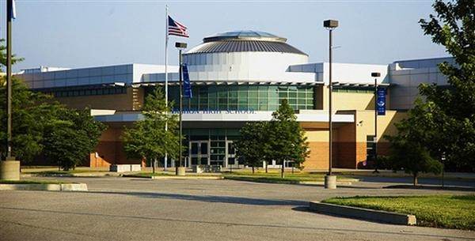
Headline  JROTC Instructors  Sergeant Major (Retired)  Walter Wright  Sergeant First Class (Retired)  Lorenzo Harris | Headline  Notes from Instructors  Together, JROTC instructors extend a warm welcome back to our returning cadets fueled with summer rest and with excitement to begin a new year! We graciously welcome cadets who are new to our school & JROTC program. |  | Headline  Notes Continuation  We (Instructors) designed classroom & project-based learning explorations that are meaningful and thought provoking. These plans, once put into action, will take our cadets to new levels of achievement. Cadet participation is vital for success!
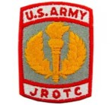 |  | Vision  JROTC will provide a quality citizenship, character, and leadership development program, while fostering partnerships with communities and educational institutions. Aligned with our vision, this year we will focus on Emotional Intelligence, STEM, LITERACY, ACT & ASVAB Prep & College & Career readiness.
Leadership Camp Graduates  Cadets Pierre Dobbins, Domonic Archie, Fatima Ndon & Devin Grant pictured; they learned much about leadership while attending camp at Scott Air Force Base, IL. Training included operations & planning, teamwork, resiliency, & physical fitness. The camp dates were June 4-8, 2018. Congratulation cadets! | 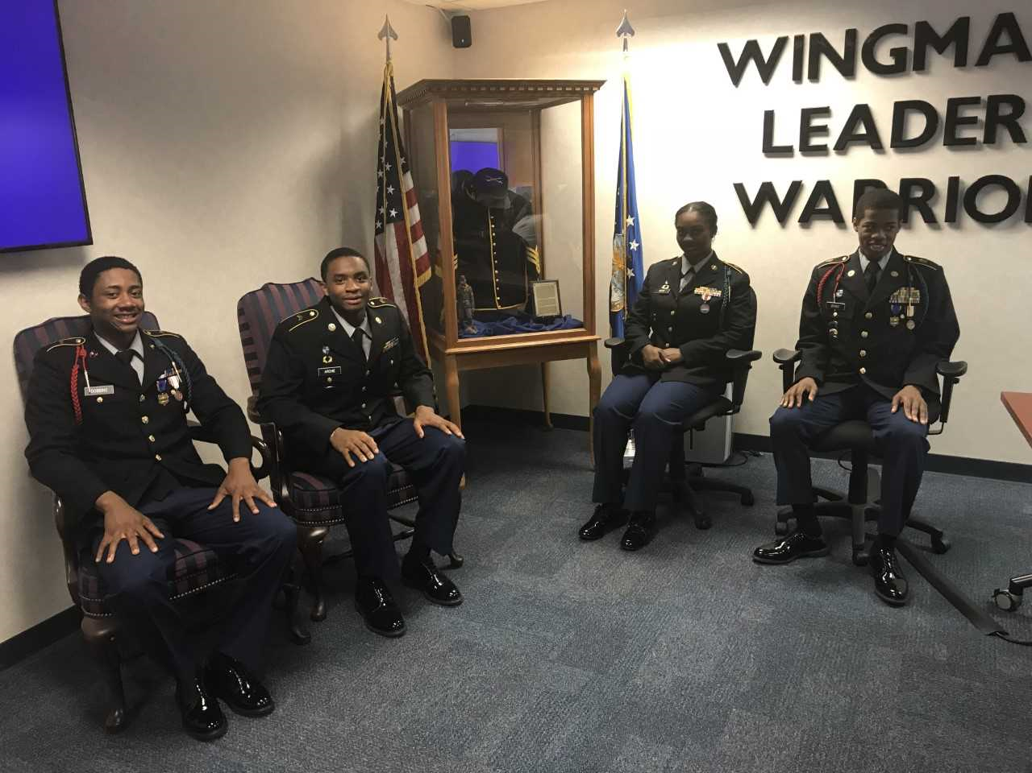
August Dates to Remember  20-24-JROTC Assessments (Learning Styles, Leadership, Personal Skills, Career, & Emotional Intelligence); 3rd & 4th Year Cadets prepare or update their resume, personal statement, goals & set-up digital portfolio.  31—JROTC Back to School Pool Party- This is one of several ways JROTC instructors get cadets motivated for the school year.  Gold Star: “Honor Unit with Distinction” Awarded to a JROTC program for achieving excellence. | 
September Dates to Remember
3-Labor Day- School Closed

4-7-Cadet Challenge physical fitness test

8-JROTC Car Wash fundraiser @ VHS

11- National Day of Service educational activities

14-Interim progress reports (cadet grades)

21-Dress for Success/Etiquette field experience
and college visit.

29-Area JROTC/SROTC teambuilding event

Website: https://www.slps.org/vashon/jrotc Email: jrotc24198@slps.org

